Fundamentals of Computer Science
Homework Set 9
December 10, 2025
- (10’) Consider the Turing machine described in the figure, starting with the following initial status. Please write the status of each step until the machine halts. Note that a status of a Turing machine should contain contents on the tape, where the current position is and what the machine state is.

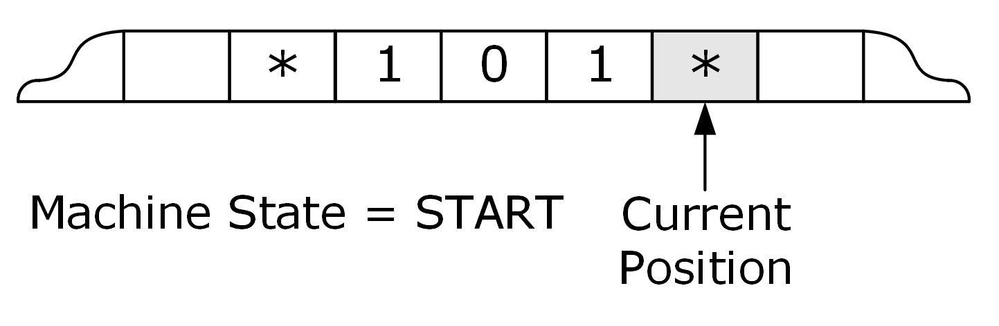

Current state | Current cell content | Value to write | Direction to move | New state to enter
START | * | * | Left | ADD
ADD | 0 | 1 | Right | RETURN
ADD | 1 | 0 | Left | CARRY
ADD | * | * | Right | HALT
CARRY | 0 | 1 | Right | RETURN
CARRY | 1 | 0 | Left | CARRY
CARRY | * | 1 | Left | OVERFLOW
OVERFLOW | * | * | Right | RETURN
RETURN | 0 | 0 | Right | RETURN
RETURN | 1 | 1 | Right | RETURN
RETURN | * | * | No move | HALT

The current state is indicated by uppercase letters. We use the "<" symbol to represent the pointer, which points to the character on the left.

This is an example with the initial state “*0*<”.
Example | Current content | Current state
STEP 1 | *0*< | START
STEP 2 | *0<* | ADD
STEP 3 | *1*< | RETURN
STEP 4 | *1*< | HALT

Write your answer below.
Your Answer | Current content | Current state
STEP 1 | *101*< | START
STEP 2 | *101<* | ADD
STEP 3 | *10<0* | CARRY
STEP 4 | *110<* | RETURN
STEP 5 | *110*< | RETURN
STEP 6 | *110*< | HALT
END.

